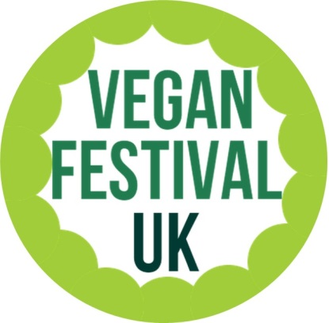

Vegan Festival Brighton welcomes exhibitors from across the UK
SATURDAY 14TH July 2018
Media – Promotion via local newspapers, radio and blog interviews leading up to final date.
Venue – Superb location in the heart of the city.
Doors open - To public 10.30am to 4:30pm.
Disabled Access – Our venue has excellent access for wheel chairs.
Final Note: Don’t forget to share these pages on your website and social media.

- http://veganfestival.co.uk/
- https://www.facebook.com/brightonveganfest/
- https://twitter.com/veganfestivaluk

Vegan Festival Booking Form
Please fill in and return to: enquiries@VeganFestival.co.uk
veganfestival.co.uk

Name:
Company Name:
Company Address
Company Email:
What items will you be supplying at vegan festival:
__________________________________________________________________________________________________________________________________________________________________
Tables required
1 table (6ft) Brighton Vegan Festival = £80
Extra Space/Table = £40
- If you require any other space please let us know.
Do you require electricity? Additional £15.00 – Limited Supply – ANYONE SUPPLYING FOOD THIS CANNOT GIVE OFF SMOKE OR STEAM OR USE GAS
Yes
No

TOTAL: _______________________________________________________
NAME: _______________________________________________________
DATE: _______________________________________________________
BACS details:
Sortcode: 40-12-55
Account number: 30398608
BOOKINGS ARE NOT CONFIRMED UNTIL PAYMENT IS MADE

If you are interested in sponsoring our event please get in touch enquiries@veganfestival.co.uk

